

**PROJECT REPORT**

DEAD OF EVIL

|  |  |
| --- | --- |
| **Semester:** | 2D Game Programing |
| **Class:** | GD05 |
| **Group:** | Duck Team |
| **Instructor:** | Tran Ngoc Tu |
| **Group Members:** | NDE-18063 - Le Van Quy  NDE-18019 - Vu Cong Tuan |

Table of Contents

[Introduction 4](#_Toc523835291)

[Game Concepts: 4](#_Toc523835292)

[Platform Requirements: 5](#_Toc523835293)

[Technique Goals: 5](#_Toc523835294)

[Ricks: 5](#_Toc523835295)

[Internal & External Tools: 5](#_Toc523835296)

[Timeline & Milestones: 5](#_Toc523835297)

[Main Game Loop 6](#_Toc523835298)

[Game Application Modules 7](#_Toc523835299)

[Game Objects: 7](#_Toc523835300)

[Characters/Units: 7](#_Toc523835301)

[Weapons: 12](#_Toc523835302)

[Projectitles: 12](#_Toc523835303)

[Level Loading: 12](#_Toc523835304)

[Terrain/Level Loading: 12](#_Toc523835305)

[Physics: 12](#_Toc523835306)

[Class diagram: 14](#_Toc523835307)

[Artificial Intelligence Modules 15](#_Toc523835308)

[Pathfinding: 15](#_Toc523835309)

[Tracking: 15](#_Toc523835310)

[Target Selection: 15](#_Toc523835311)

[Behaviors: 15](#_Toc523835312)

[Graphic Engine 16](#_Toc523835313)

[Rendering System: 16](#_Toc523835314)

[Models: 16](#_Toc523835315)

[Animations: 16](#_Toc523835316)

[Textures: 16](#_Toc523835317)

[2D Graphics: 16](#_Toc523835318)

[Particles: 16](#_Toc523835319)

[Text: 16](#_Toc523835320)

[Camera: 16](#_Toc523835321)

[Renderer: 16](#_Toc523835322)

[Display Managers: 16](#_Toc523835323)

[Lighting, Shadows & Other Special Effects: 16](#_Toc523835324)

[Networking 17](#_Toc523835325)

[Client & Server Operation 17](#_Toc523835326)

[Protocol 17](#_Toc523835327)

[Packet Structure: 17](#_Toc523835328)

[Game Specific Information 17](#_Toc523835329)

[Online Chat: 17](#_Toc523835330)

[Other Server: 17](#_Toc523835331)

[Audio 17](#_Toc523835332)

[Audio format 17](#_Toc523835333)

[Compression/Decompression: 17](#_Toc523835334)

[Sound Manager: 17](#_Toc523835335)

[Special Audio Effects: 17](#_Toc523835336)

[User Interface & Input 18](#_Toc523835337)

[Coding Standards 26](#_Toc523835338)

[Development Tools 26](#_Toc523835339)

[Appendices 26](#_Toc523835340)

[Terms and acronyms 26](#_Toc523835341)

[References 26](#_Toc523835342)

[Other issues 26](#_Toc523835343)

[Document Format 27](#_Toc523835344)

# Introduction

After finishing the second semester at my school - VTC Academy and I will be working on a project for this term - 2D video game, which is true to my curriculum as 2D Game Programming. The project was implemented by the Duck Team, starting from my idea to implement the code into the game. These advances have helped me to improve my knowledge and learn a lot.

## Game Concepts:

**-** *About this content story*

Borzandar is a kingdom full of joy and happiness, Demon Lord, the demon who invaded and destroyed, everyone in the kingdom was captured, the one who could use the Kal stone was the princess Hina who was locked in the cave by him, the chief Tol'vir had tried with him but failed, Time is running out, someone needs to rescue the princess to restore the kingdom. You, you are the chosen one and you can destroy the DemonLord and bring life to the kingdom, now!

**-** *About this Gameplay*

Inspired by the Dark Souls series, my team designed a game called Dead Of Evil, we turned 3D games into pixel graphics 2D games, characters will inherit some mechanisms of the souls series is jumping, roll and mana bar and update stats. Unlike slashing games, you have to be really careful about enemy attacks and mana bars to move and handle flexibly in the game, even a small mistake can die.

**-** *Explore a dark world*

Overcoming fearsome enemies and deadly traps as you venture through many different landscapes and search for the Boss to destroy and rescue the princess.

***-*** *Brutal combat*

With the sword in hand, it can wield all enemies along the way, trying to flexibly use the skills to finish the target as quickly as possible.

***-*** *Upgrade*

Finishing off more monsters will increase the stats after leveling up.

## Platform Requirements:

- Android: 5.0 or high

RAM: Minimum 2G

- OS: Windows 7 and 10

Minimum Hardware:

* I3 1.3 GHz Processor
* 2GB RAM
* Direct3D 9.0 support
* 100MB Hard-Drive space available.
* 1.8 GHz Processor
* 512MB RAM

# Technique Goals:

Create a game can run on desktop .

The game uses 2D physics with cocos2dx and self - writing

## Ricks:

The game is tested with different machine configurations, it's good that it still works fine even though the old or low versions have a bsit of lag.

## Internal & External Tools:

Used IDE : Visual studio

Tool :

+ Tiled : create tile map

+ Photoshop/Illustrator : create assets as background, sprite,...

+ Texture Packer GUI : create animation …

+ Violet Editor, Draw.io: Design class diagram and flow for the game

## Timeline & Milestones:

The game started to build a prototype version in 1 month and completed in about 2 months.

# Main Game Loop

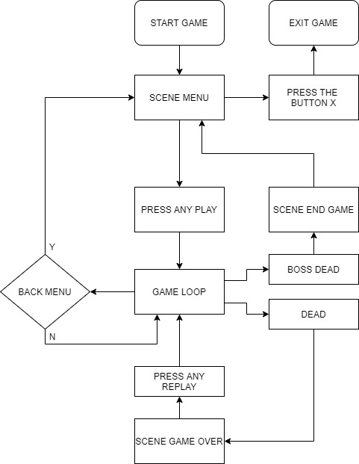

# Game Application Modules

## Game Objects:

**Player :**



**Enemy :**

* Enemy Fly : ,



* Enemy On land: , , , , C:\Users\Admin\AppData\Local\Microsoft\Windows\INetCache\Content.Word\attack-A6.png



**Boss :**



## 

**Obstacles**: , ,



**Object Item**: , ,

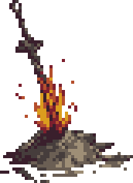

## Characters/Units:

Players have different skills and increase the stat after leveling up. Players have different skills and increase the stat after leveling up.

**Player :** PlayerSplash (1)

Properties: Upgrade after each level (level <= 10)

* HP : 100 | + 0
* MP : 100 | + 0
* Speed : 3.0 | + 0.15
* Jump : 4.5 | + 0.1
* Attack : 35 | + 9
* Time Roll : 4 | + 0.1

**Enemy**:

* Bat: BatFly_01

Properties:

* + HP : 50
  + Speed : 1
  + Vision range : 100
  + Dame : 15
  + Exp : 20
* Winzard: winzard_Idle (1)

Properties:

* + HP : 75
  + Speed : 0
  + Vision range : 400
  + Damage : 10
  + Exp : 50
* DullnessShoot: idle-1

Properties:

* + HP : 70
  + Speed : 0
  + Vision range : 400
  + Damage : 10
  + Exp : 35
* LothricKnight: LothricKnight_idle (1)

Properties:

* + HP : 150
  + Speed : 1, 2
  + Vision range : 50
  + Damage : 15
  + Exp : 50
* SoldierGuard: soldierguard_idle (1)

Properties:

* + HP : 85
  + Speed : 0
  + Vision range : 45
  + Damage : 25
  + Exp : 45
* Skeleton: idle-ED1 (1)

Properties:

* + HP : 100
  + Speed : 1, 1.5
  + Vision range : 40
  + Damage : 15
  + Exp : 40
* TreeHurt: C:\Users\Admin\AppData\Local\Microsoft\Windows\INetCache\Content.Word\attack-A6.png

Properties:

* + HP : 60
  + Speed : 0
  + Vision range : 35
  + Damage : 20
  + Exp : 30

**Boss**: Buffalo_Idle (1)

Properties:

**Face One: Face Two:**

* HP : 2000 | + 500
* Speed : 1 | + 1.5
* Vision range : 400 | + 100
* Damage :

+ Skill Attack A : 10 | + 5

+ Skill Attack B : 15 | + 5

+ Skill Fire Ball : 10 | + 0

**Obstacles**:

* Spikes: 

Properties:

* + Speed : 1
  + Damage : 20
* Traps: traps

Properties:

* + Damage : 50

**Item**:

* Bonfire: 

Properties:

* + HP player : + 100 %
* Medicine : item-hp

Properties:

* + HP player : + 50

## Weapons:

Visual effects are mainly drawn by animation fame by fame.

## Projectitles:

In our team game, there are weapons such as Duness's name, the ball fire of Winzard and Boss, they are used separately from the main weapon, when they hit the wall and will disappear, if hitting the character will Display blood effects on characters and characters, too.

## Level Loading:

All the levels, images and locations of the objects we have designed in a software called Tiled, When going to another level, all the maps I will default to are in the form of "Map %d" , in which I only need to increase the index level in the game to correspond to the next level.

## Terrain/Level Loading:

The maps, sounds and effects we will load up before going into the main game, my map uses square collider and bullets can be square circle .... they work very well.

## Physics:

As for collision handling, we use the Physics body of the system, and there are some places that have to be handled by code themselves.

## Class diagram:

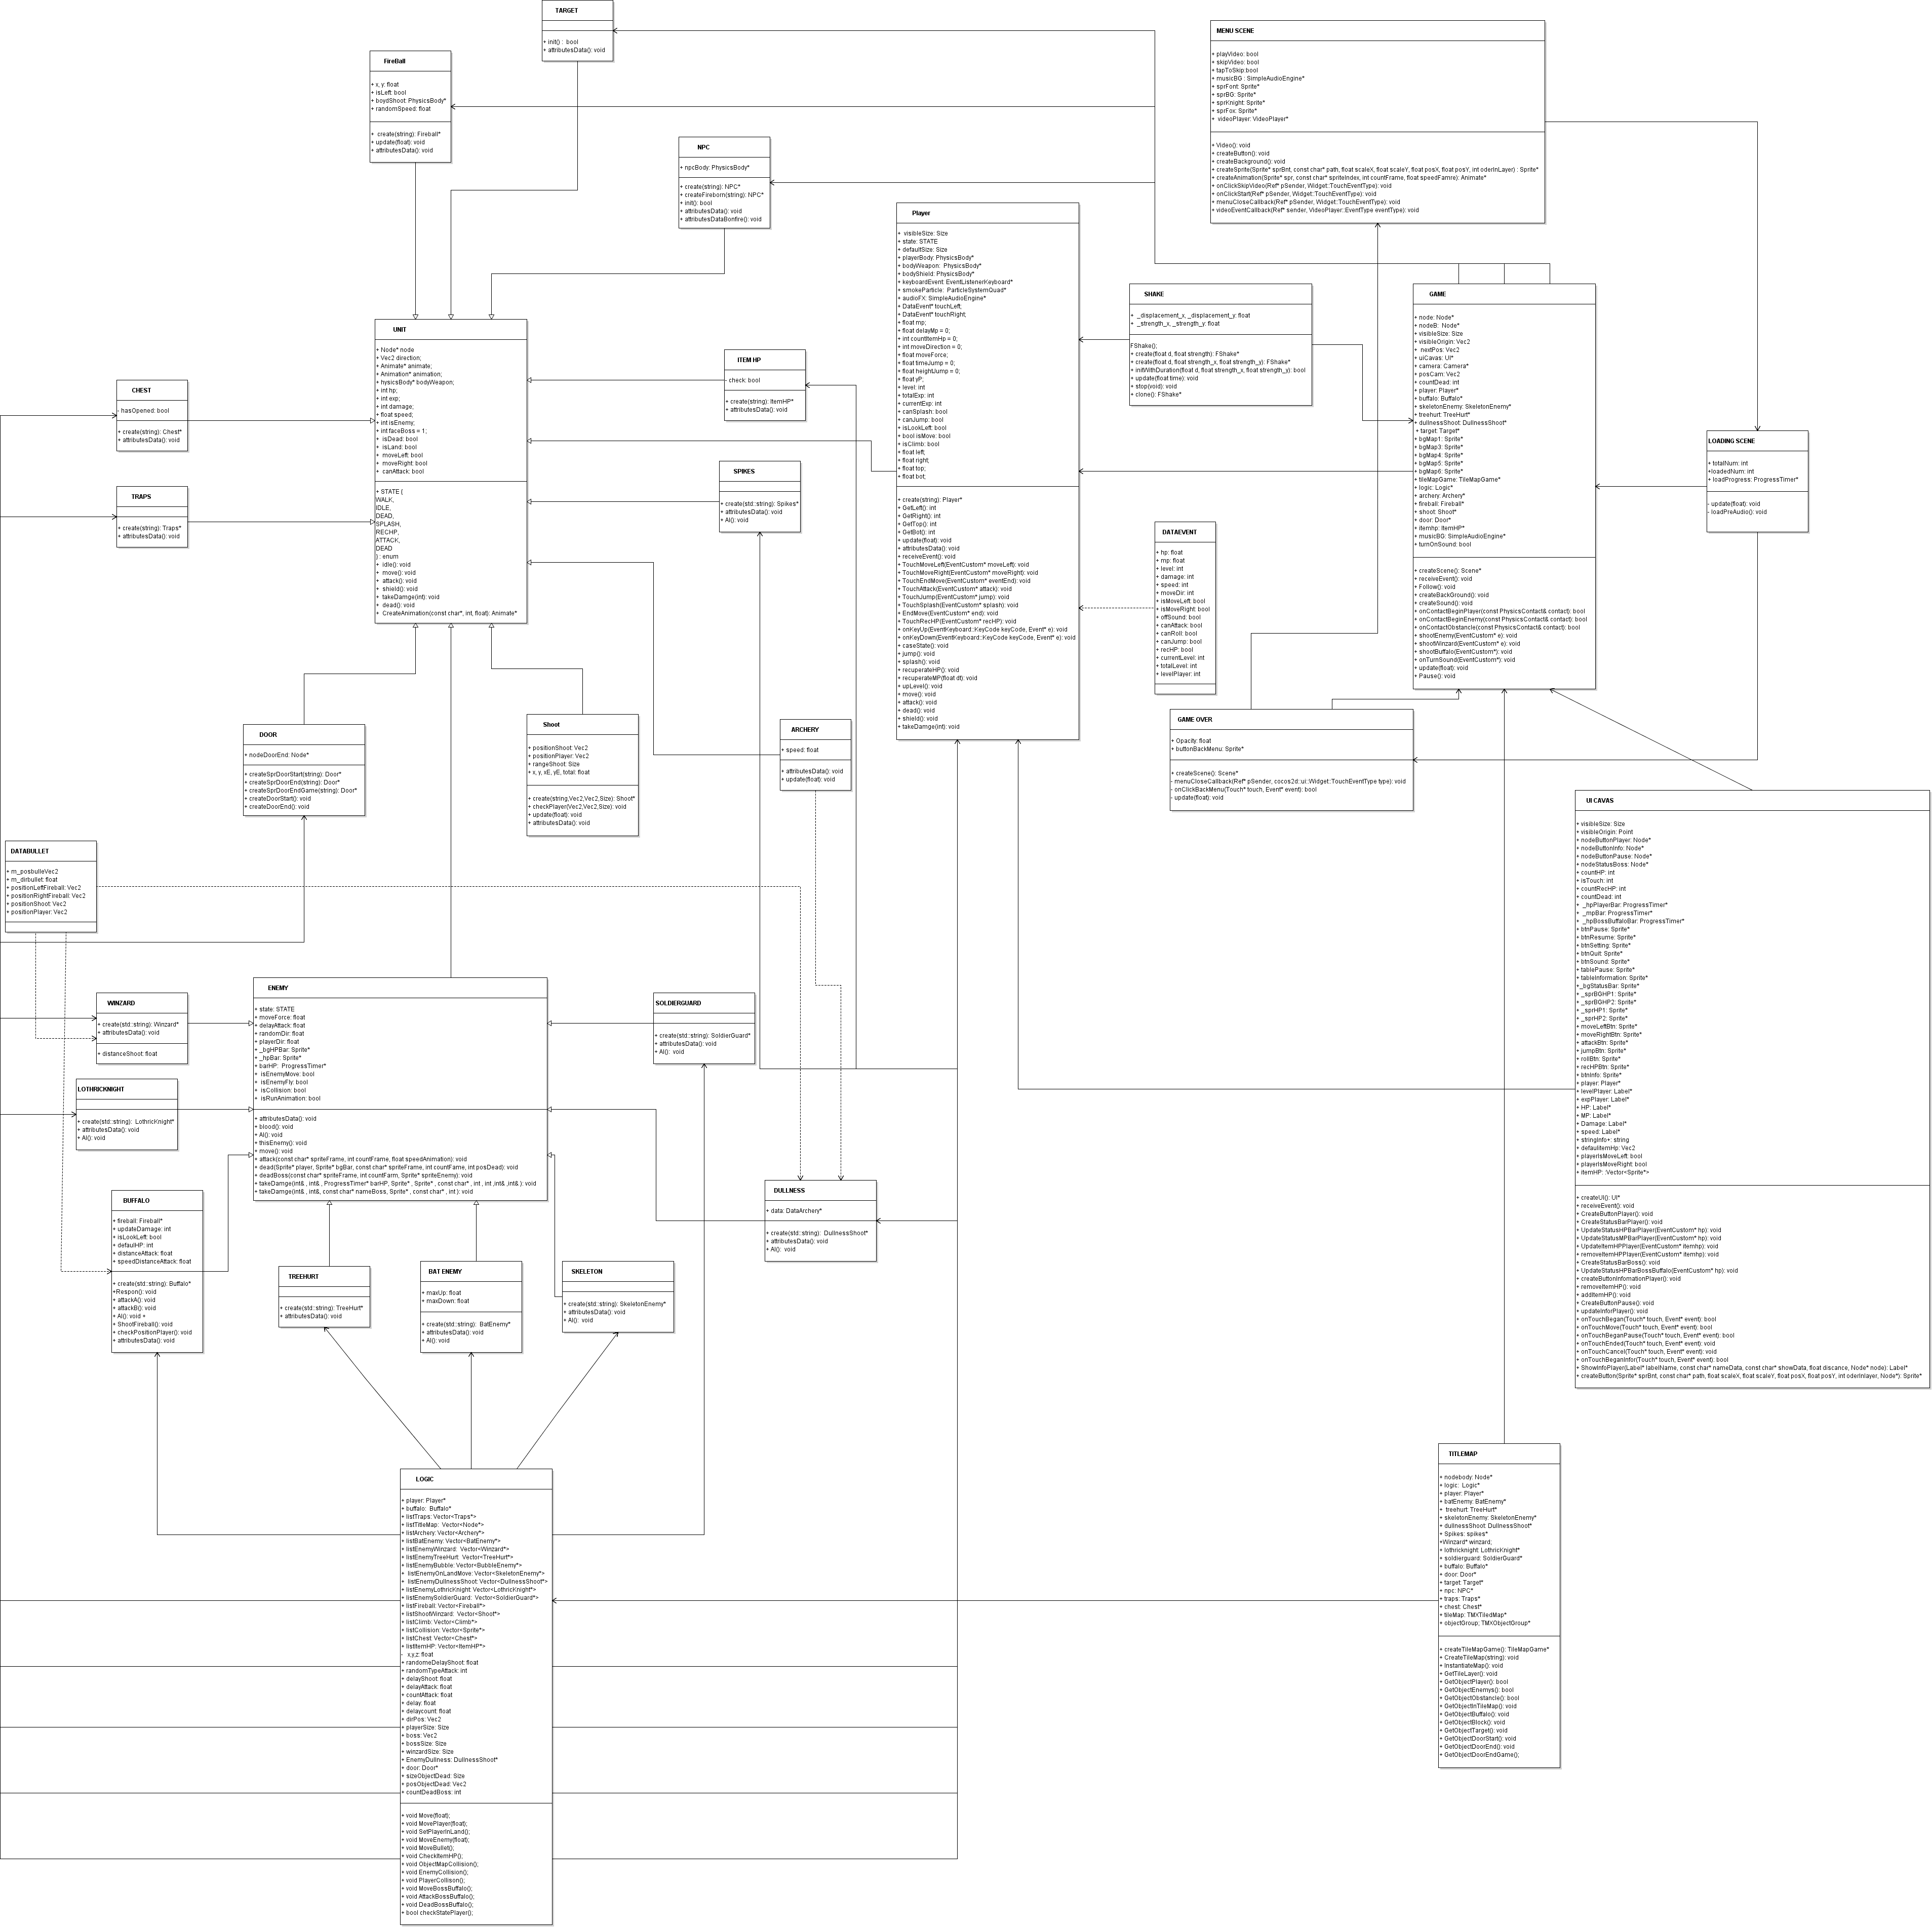

Link Image Class Diagram:

# https://drive.google.com/drive/folders/1moNPH1yRIjVGSzWkOgnGSeVMIjEn4pXL?usp=sharing

# Artificial Intelligence Modules

Pathfinding

In my game, use mathematical formulas to handle the way, create points on the map if the enemy moves, it will change direction, use physics body to check collisions with the player.

Tracking

In my game I use mathematical formulas to handle tracking

Target Selection

For targeting, our team used physical and spacing with code

Behaviors

The behavior of the enemy and the boss, our team used physical and distance with the code.

# Graphic Engine

## Rendering System:

Direct3D 9.0

## Models:

Do not use models

## Animations:

My team uses images for object behavior

Eg: Player, Enemies, Boss with moving animations moved, hit, died ....

## Textures:

Use picture as jpg, png.

Use texture built-in system cocos2dx

## 2D Graphics:

Load 2D graphics by built-in system cocos2dx

## Particles:

Load text by built-in system cocos2dx

## Text:

Font Arial, Marker Felt, Pixel.

Load text by built-in system cocos2dx

## 16Camera:

Use camera by built-in system cocos2dx

## Renderer:

Use renderer by built-in system cocos2dx

## Display Managers:

Use Display by built-in system cocos2dx

## Lighting, Shadows & Other Special Effects:

Use Lighting, shadows and effects by built-in system cocos2dx

# Networking

The game is not support online system/Networking.

# Audio

## Audio format

My game use mp3 and wav format for audio

## Compression/Decompression:

None

## Sound Manager:

I used Simple Audio Engine of Cocos2dx

## Special Audio Effects:

None

# User Interface & Input

**User Interface**:

* Video story

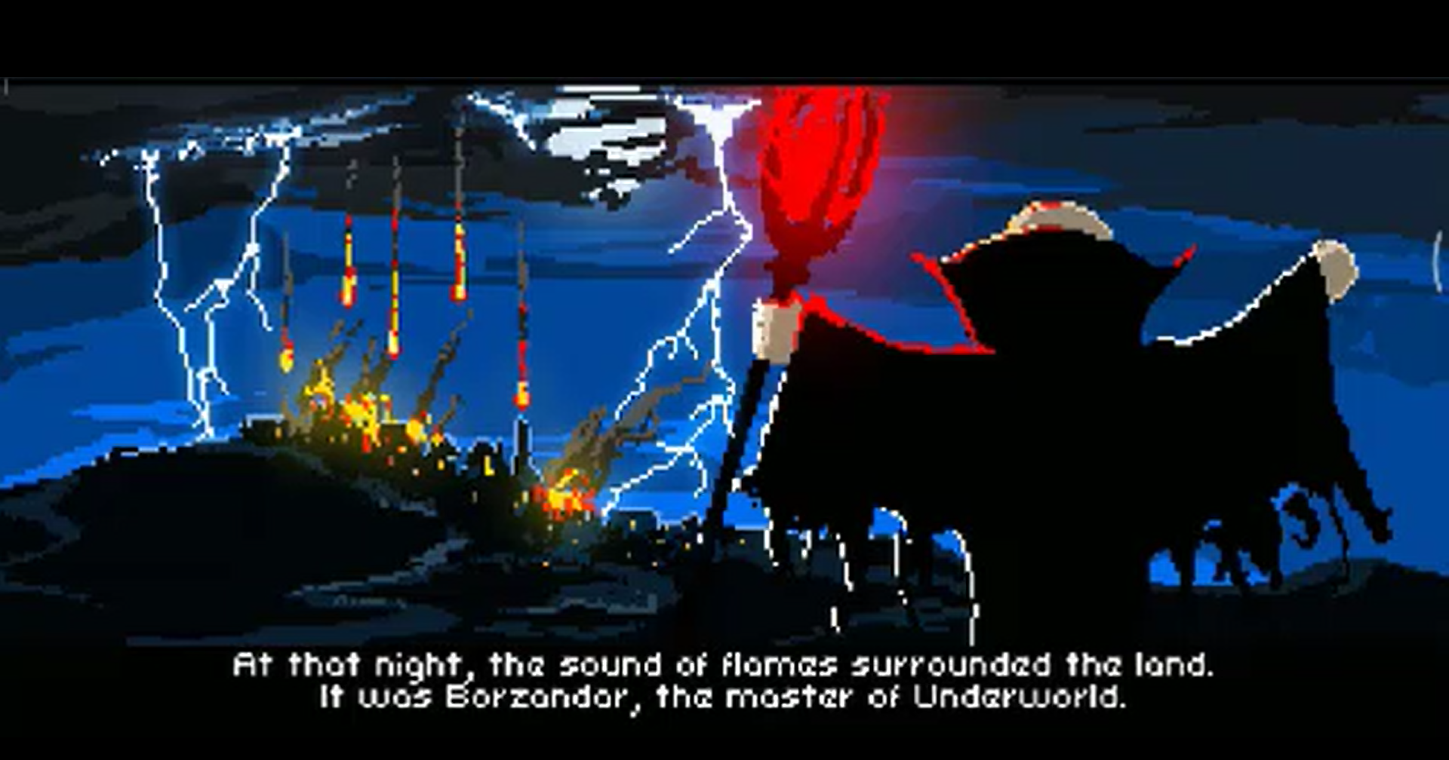

* Scene Menu

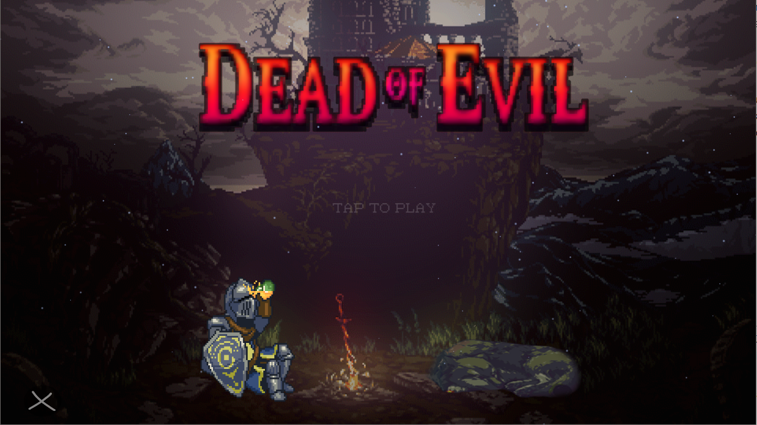

* Scene Loading

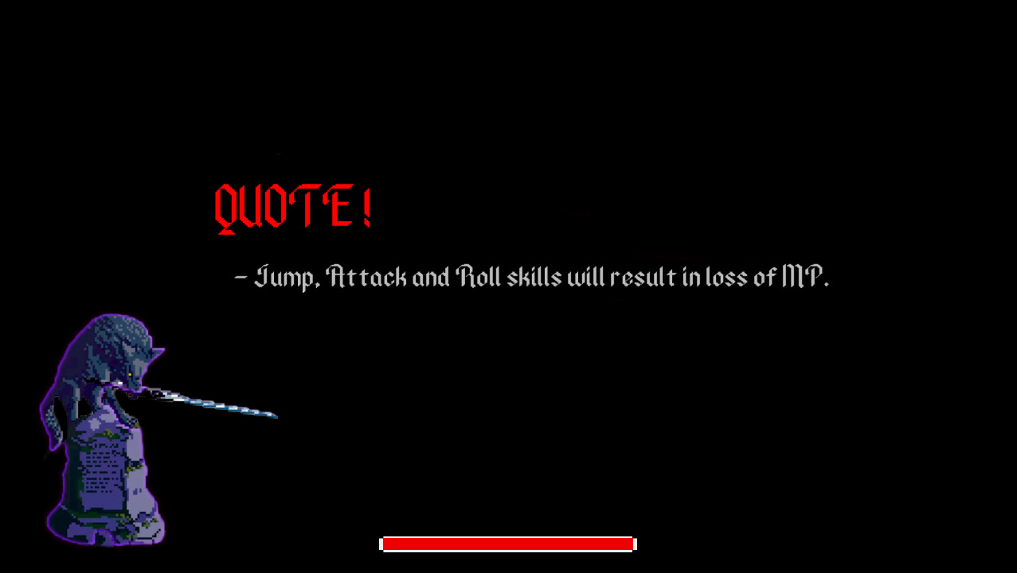

* Scene Game Level 1

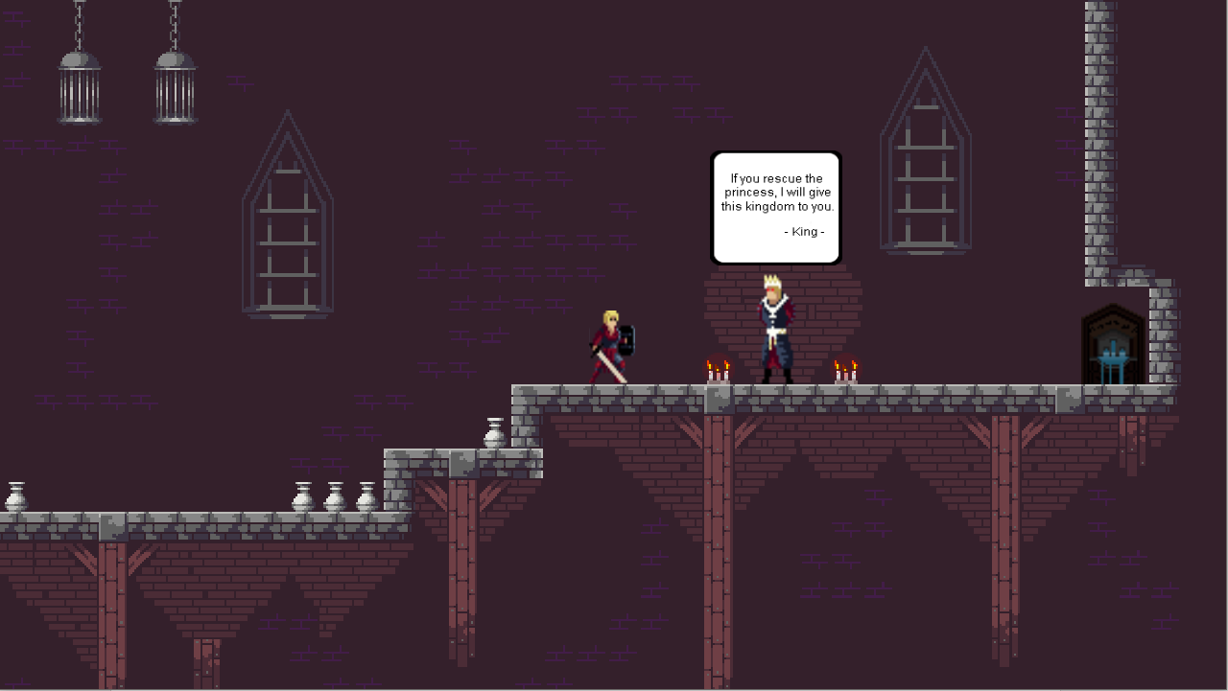

* Scene Game Level 2

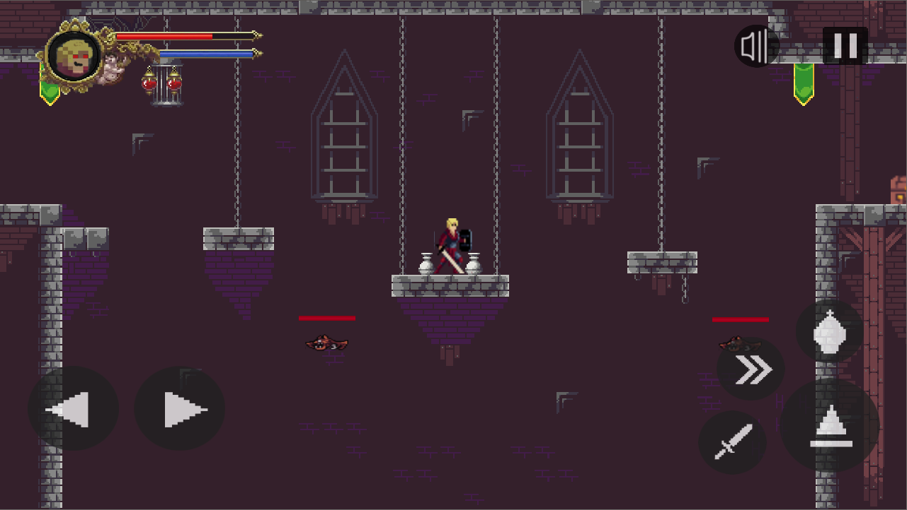

* Scene Game Level 3

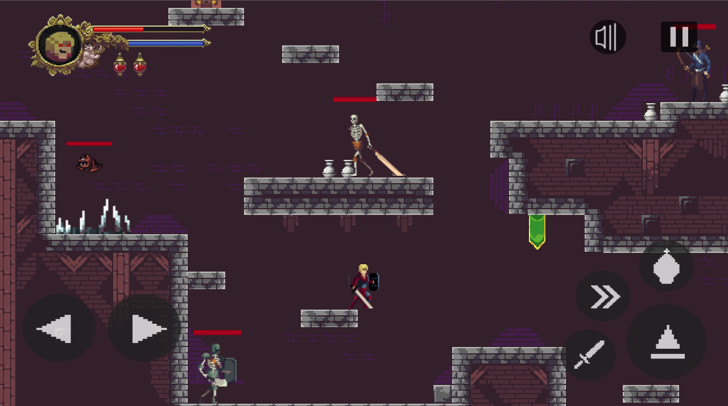

* Scene Game Level 4

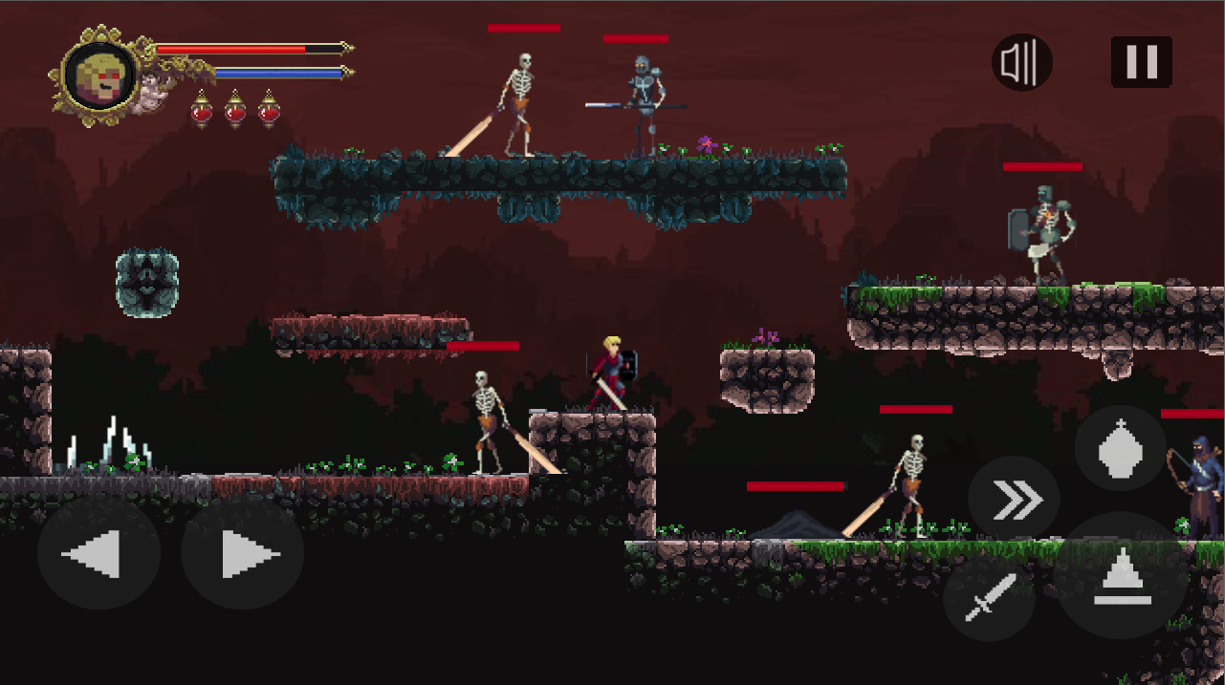

* Scene Game Level 5

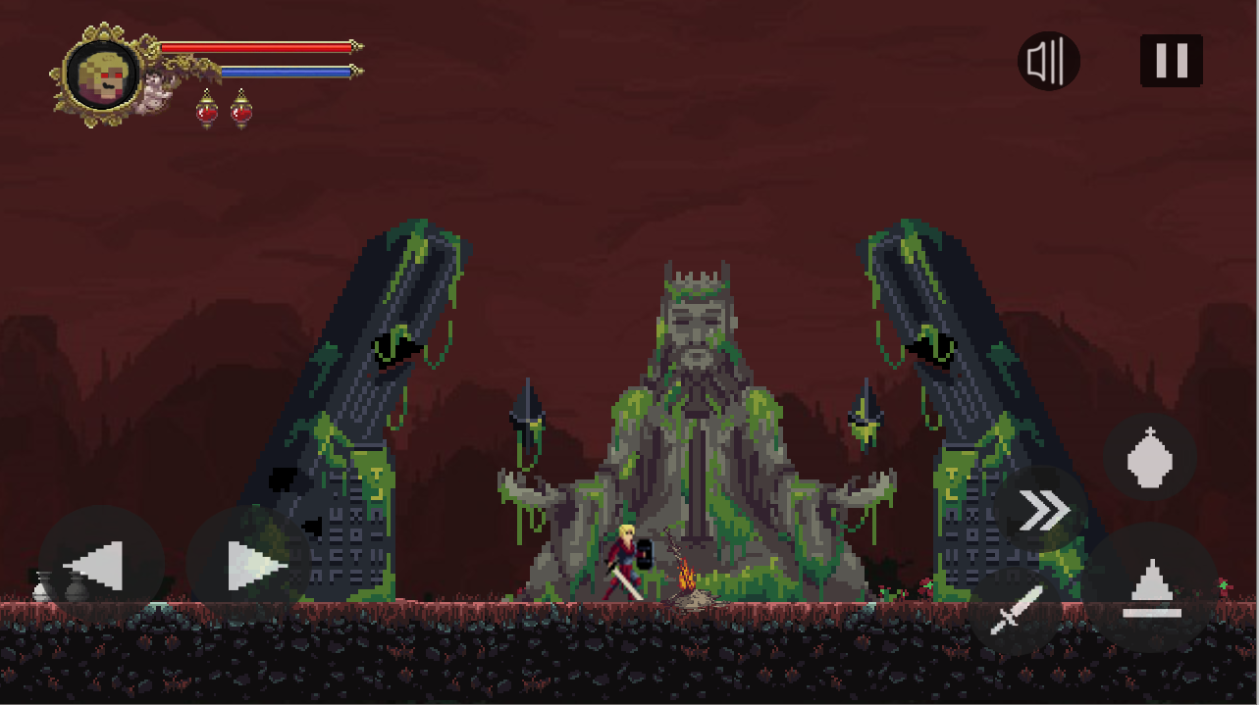

* Scene Game Level 6

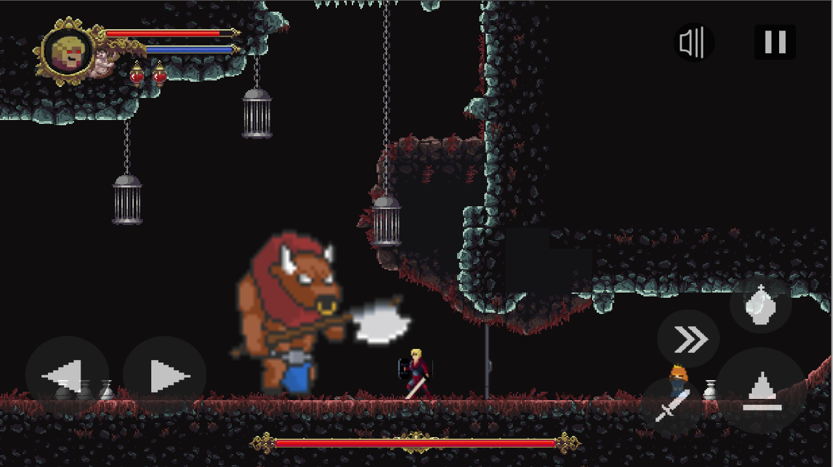

* Scene Game Over

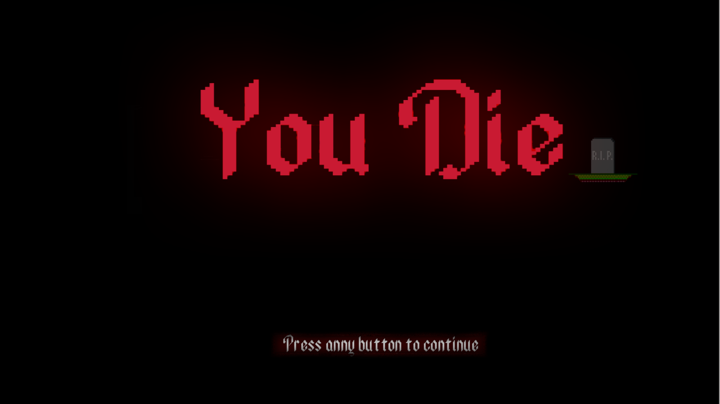

* Scene Game Win

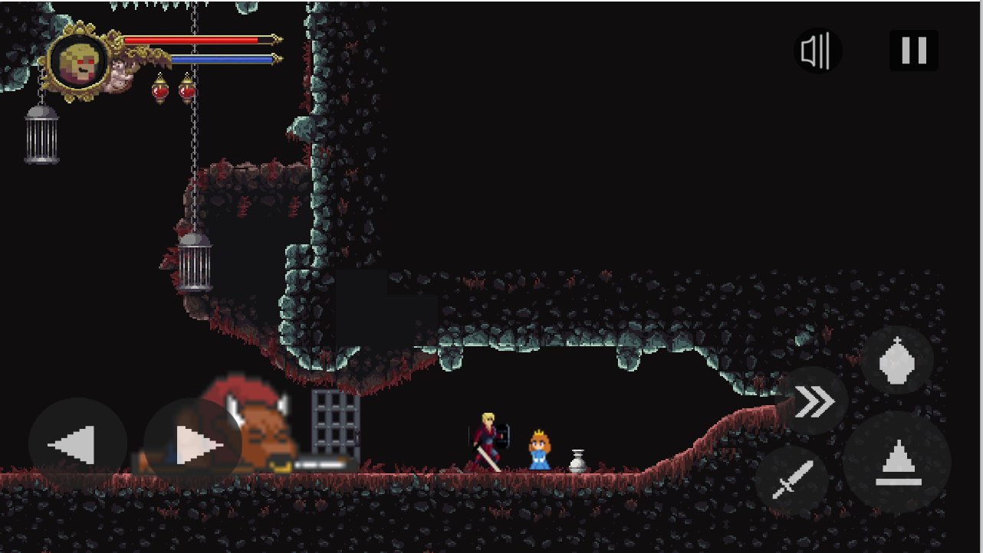

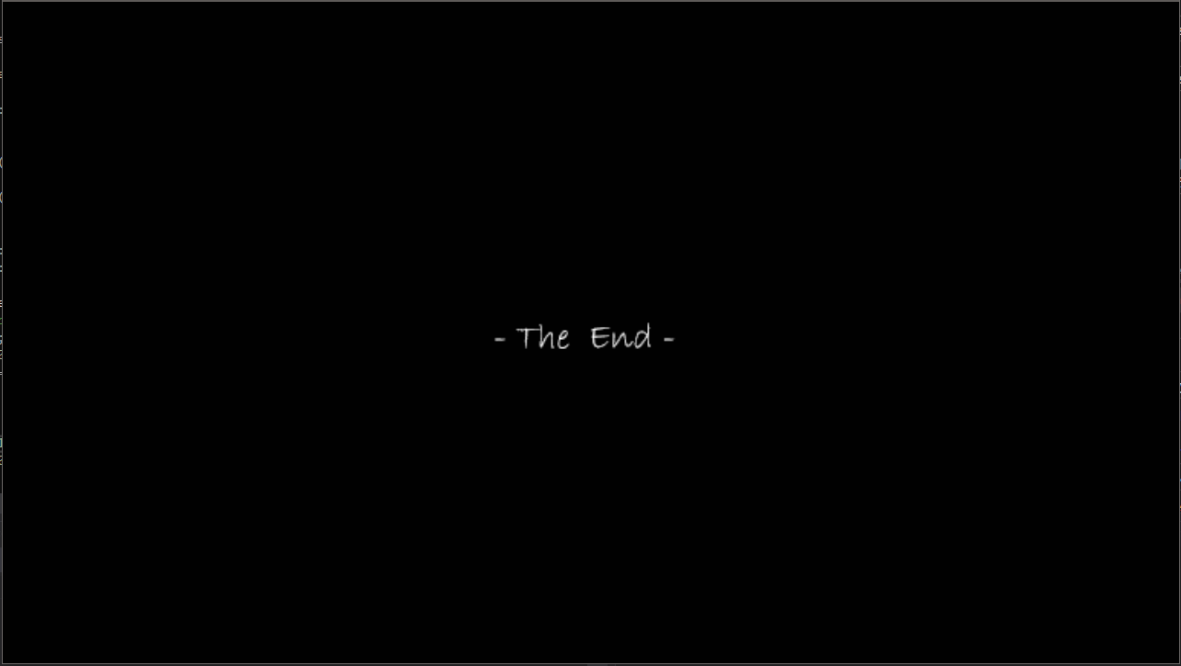

**Button:**

* Button game

, , , , ,



* Button UI

Start Icon: , Close Icon : , Info Icon :



Resume Icon :  , BackMenu Icon : 

Music icon : 

Replay Icon : 

Information :

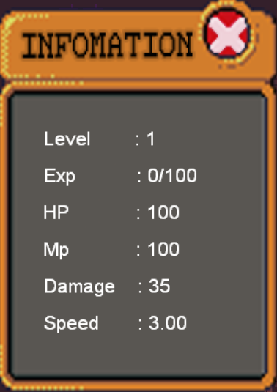

**Input**:

Desktop : Use traditional input is mouse and keyboard to handle actions in game.

Player:

* A and D : Move left or right
* Space : Jump
* J : Attack
* Shift : Roll
* R : Use Item HP

# 

# Coding Standards

**-** Class name : capitalize the first letter

**-** Function name : use verb and lowercase first letter

**-** Normal variable : lowercase

**-** Define : uppercase

**-** Element of enum : Capitalize full letter

# Development Tools

**-** Visual Studio 2019

**-** Photoshop 2019

**-** Tiled

**-** Texture Packer

- The Microsoft tool

# Develop Idea in future

+ Add more map in game.

+ Add more class characters in the game.

+ Add skill system for character

+ Add in-game items and currency

+ Add in-game items and currency

+ Add more enemies with different attributes

# Appendices

## Terms and acronyms

The game is owned and intellectual by group Duck Team.

## References

* <https://docs.cocos2d-x.org/api-ref/cplusplus/v3x/> : API of cocos2dx
* [https://stackoverflow.com/ how-to-shake-screen3](https://stackoverflow.com/questions/26551365/how-to-shake-screen-in-cocos2dx-3) : Command pattern is used.
* <https://www.stdio.vn/articles/categories/cplusplus-22/> : Document
* <https://stackoverflow.com/> : Bug fixes

## Other issues

This game may contain violent content not suitable for all ages and not intended for children.

# Document Format

***Report corver:***

*The cover is printed in blue.*

*With the format as the first page of this document.*

***Paper Size:***

*The report is presented on A4 size paper (210 mm x 297 mm)*

***Top header***

*Bên trái: Logo của VTC Academy*

*Bên phải: Tên Project*

*Font chữ: Time New Roman*

*Font size: 13pt*

***Bottom header***

*Left: Class\_Name –Project\_Name*

*Right: Page\_Number*

*Font Name: Calibri*

*Font size: 13pt*

***Report Content:***

*Font Name: Calibri*

*Font size: 13pt*

*Minimum 15 pages*

***Page margin (for A4 size paper)***

*Top: 20 - 25 mm;*

*Bottom: 20 - 25 mm;*

*Left: 30 - 35 mm;*

*Right: 15 - 20 mm;*